|  |  |  |  |
| --- | --- | --- | --- |
| 1 | | 888.0 | |
| NUMERO DE FRONTERAS | | ENERGIA AGREGADA | |
|  | | | |
| NO | | 0 | |
| CONTRATO | | VENCIMIENTO CONTRATO | |
|  | | | |
| 5,258,341 | 85 | | 181,340 |
| INGRESO 2020 | DÍAS CERTIFICADOS 2020 | | ENERGIA RESPALDADA 2020 |
|  | | | |
| 1,796,107 | 88 | | 78,020 |
| INGRESO 2021 | DÍAS CERTIFICADOS 2021 | | ENERGIA RESPALDADA 2021 |

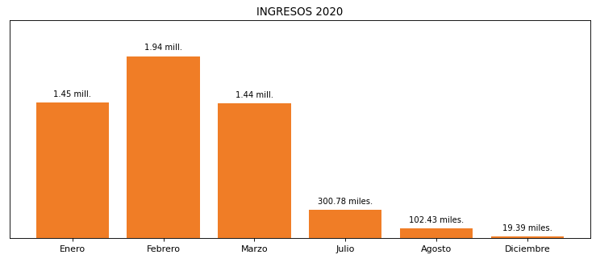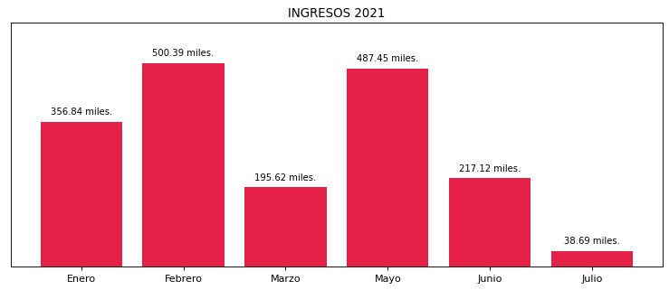

|  |
| --- |
| **CENTRO EMPRESARIAL BUENAVISTA**  USUARIO |

|  |
| --- |
| **Edwin Torres**  Ejecutivo de cuenta |

|  |
| --- |
| **Mario Barranco / Gerente / gerenciacebuenavista@gmail.com**  Primera fecha: PUNTO FOCAL |

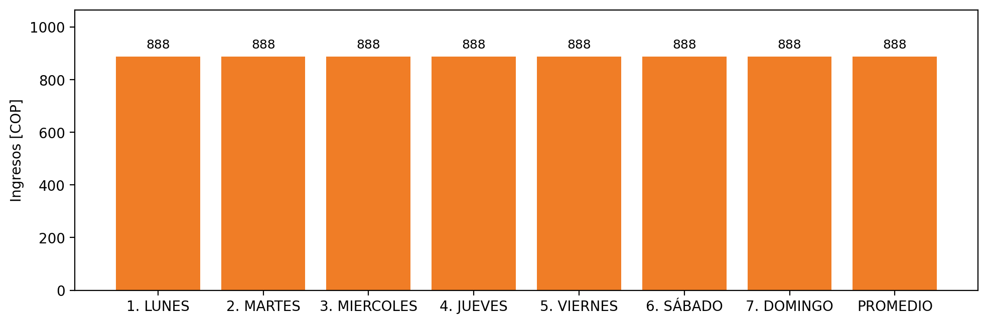

|  |  |  |  |  |  |  |  |  |  |
| --- | --- | --- | --- | --- | --- | --- | --- | --- | --- |
| **FRONTERA COMERCIAL** | **TIPO DDV** | **COD SIC** | **PREDIO** | **PROMEDIO** | **MARGEN** | **ÚLTIMA DESCONEXION** | **DÍAS CERTIFICADOS** | **ACTUALIZACION** | **PROXIMA PRUEBA DDV** |
| CENTRO EMPRESARIAL BUENAVISTA | Frt36038 | Frt29185 | Prd01518 | 888 | 3,55 | 2020-12-13 | 88.0 | 2022-01-28 | 2021-11-30 |